What’s on the Computer Science Principles
1st Semester Final Exam?!?
Unit 1 – The Internet
Lesson 1.2
Know the difference between binary and non-binary questions.
- Write 2 examples of binary questions.

1. Did you eat dinner last night?
2. Is it snowing outside?

- Write 2 examples of non-binary questions.

- What did you eat for dinner last night?
- How much snow did you get at your house?

Lesson 1.3
Define each of the following words: Bit Rate, Bandwidth, and Latency

Bit Rate – the number of bits that are conveyed or processed per unit of time. e.g. 8 bits/sec.

Bandwidth –Transmission capacity measure by bit rate

Latency – Time it takes for a bit to travel from its sender to its receiver.

Lesson 1.5
Know how to change numbers from decimal to binary and binary to decimal
- What is the decimal number 45 written as a binary number?
101101

- What is the binary number 10011 written as a decimal number?
19

If you increase a binary number by 1 bit, how many more options will you have? How about 3 bits?
Each time we add another binary digit we double the possible values.
- One binary digit has 2 possible values (0 and 1)
- Two binary digits have 4 possible values (0, 1, 10, 11)
- Three have 8 possible values
- Four have 16 possible values
- Five have 32 possible values
- Six have 64 possible values
If Damonte Ranch High School offers 84 different classes, how many bits would they need in order to assign each class to a different binary number?

7 - 1010100

Lesson 1.6
What is the definition of a protocol, algorithm, and hierarchy?
Protocol – a set of rules governing the exchange of or transmission of data between devices.
Algorithm –
Hierarchy -

Lesson 1.9
What is an IP address? And who/what are assigned IP addresses?
A number assigned to any item that is connected to the Internet.

How many IP addresses could you create with 8 bits?
0 – Traditional IP addresses are 32 bits long.

How many more IP addresses does IPv6 (128 bits) have than IPv4 (32 bits)?
A lot – IPv4 has 4 Billion and IPv6 has 340 Undecillion

Lesson 1.10
Know the following router vocabulary: Fault tolerant, redundancy, and the difference between routing
and broadcasting.
Fault tolerant – the property that enables a system to continue operating properly in the event of the failure of some (one or more faults within) of its components.
Network Redundancy – having multiple backups to ensure reliability during cases of high usage or failure.
Routing – forwarding data across a network.
Broadcasting - transmitting

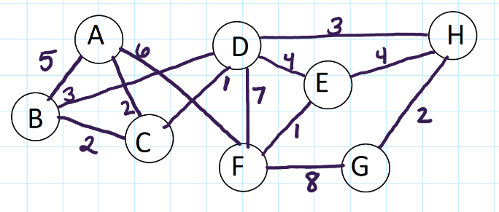
Be able to analyze network diagrams:
- What is the most efficient path from B to G?
BàDà H à G (Because it is 8 and that is lowest number)

- What number of connections can be lost so E can no longer communicate with H?
3 – E à D, D à H, Eà H

- How many connections could be removed and the network still be fault tolerant?
1 -Only one connection can be removed for the network to remain fault tolerant.

Lesson 1.11 https://tinyurl.com/y6wl7uxr
Explain how packets are used to send data to a receiver.
Packets are sent through routers
Packets - Small chunks of information that have been carefully formed from larger chunks of information.

When packets are sent what is contained in the message?
10s of billions of bits (1s and 0s)
To and from IP address

Why do we use packets to send data?
Because it is more efficient. If we were to send all of the data in one large packet we would run the risk having the data dropped, because it would be too big. By breaking the transmission up into smaller packets TCP can monitor that all packets get to their destination and reassembled.

Lesson 1.12
Explain how the Domain Name System (DNS) works with IP addresses.
DNS associates names, like www.example.com with the corresponding addresses. Your computer uses the DNS to look up domain names and get the associated IP address, which is used to connect your computer to the destination on the internet.

What is the purpose of the DNS?
Open and public communication protocol

Unit 2 – Digital Information
Lesson 2.1
Order the following file sizes from smallest to biggest
Megabyte, Exabyte, Kilobyte, Gigabyte, Terabyte, Petabyte
Kilobyte – One Thousand Bytes (10³)
Megabyte – One Million Bytes (10⁶)
Gigabyte – One Billion Bytes (10⁹)
Terabyte – One Million Million (10¹²)
Petabyte – One Quadrillion (10¹⁵⁾
Exabyte – Quintillion Bytes (10¹⁸)

Lesson 2.2
What does it mean to take a heuristic approach to solving a problem?
A problem solving approach (algorithm) to find a satisfactory solution where finding an optimal or exact solution is impractical or impossible.

Lesson 2.3
Define Metadata
Data that describes other data.

If I was creating a digital picture by assigning each pixel an RGB value, what are some examples of metadata that you would want to include?
A digital image may include metadata that describe the size of the image, number of colors, or resolution.

Lesson 2.4
What base number system is each of the following?
Decimal 0,1, 2, 3, 4, 5, 6, 7, 8, 9
Binary 0, 1
Hexadecimal 0,1, 2, 3, 4, 5, 6, 7, 8, 9, A, B, C, D, E, F

Using 12 bits, four for each R, G, B value, (this does not make sense, change to 24 bits, 8 each) How would you represent the following colors:
Using 6 hexidecimals, 2 for each R, G, B, value, (0-F)How would you represent the following colors:
- Red Bits – R 11111111 G 00000000 B 00000000 Hexadecimal – FF0000

- Green Bits - R 000000000 G 11111111 B 00000000 Hexadecimal – 00FF00

- Blue Bits - R 000000000 G 00000000 B 11111111 Hexadecimal – 0000FF

- White Bits - R 11111111 G 11111111 B 11111111 Hexadecimal – FFFFFF

- Black Bits - R 000000000 G 00000000 B 00000000 Hexadecimal – 000000

Lesson 2.5
What is the difference between lossy and lossless compression.
Lossy Compression - (or irreversible compression) a data compression method that uses inexact approximations, discarding some data to represent the content. Most commonly seen in image formats like .jpg.

Lossless Compression - a data compression algorithm that allows the original data to be perfectly reconstructed from the compressed data.

Can you restore your data to its original state with lossy compression? Lossless compression?
Data can be stored to its original state using Lossless compression.

What are the advantages and disadvantages of using a lossy compression?
Advantages: smaller file sizes than Lossless compression. Disadvantages: Loss of quality.

What are the advantages and disadvantages of using a lossless compression?
Advantages: No loss of quality, slight decreases in image file sizes. Disadvantages: Larger files than if you were to use lossy compression.

Unit 3 – Intro to Programming
Lesson 3.4
What is pair programming and why do we us it? What are the roles of pair programming?
Pair programming helps people make better programs by working together. The main idea is that two programmers use a single computer to collaboratively develop code.
- There is only one computer and two programmers.
- Assign one student "driver" and the other "navigator". Don't worry, you'll switch often.
- The driver is the only one to touch the keyboard/mouse.
- The navigator should look for problems in the code and keep track of the high-level plan.
- Both driver and navigator should be communicating constantly by talking out loud and sharing ideas.
- Driver and navigator roles must switch when the teacher indicates, typically every 3-5 minutes.

What picture would you create if you ran the following code?
Rectangle
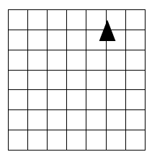
TurnLeft( )
Move Forward( )
Move Forward( )
Move Forward( )
TurnLeft( )
Move Forward( )
Move Forward( )
PenUp()
PenDown( )
TurnLeft()
Move Forward( )
Move Forward( )
Move Forward( )
TurnLeft( )
Move Forward( )
Move Forward( )

Using the four basic commands: PenUp( ), PenDown( ), MoveForward( ), TurnLeft( ), Write the most efficient program for creating a square with a side length of 2.
PenDown()
TurnLeft()
MoveForward()
MoveForward()
TurnLeft()
MoveForward()
MoveForward()
TurnLeft()
MoveForward()
MoveForward()
TurnLeft()
MoveForward()
MoveForward()
PenUp()

Lesson 3.5 - https://tinyurl.com/y9jyze8m
Why do we create and use functions?
Defining functions is an example of how computer scientists use abstraction to solve problems.

Function - A named group of programming instructions. Functions are reusable abstractions that reduce the complexity of writing and maintaining programs.

If I created a function for drawing a hexagon, what would be 2 good options for naming the function?
drawShape()
drawHexagon()

What would be a bad options for naming the function?
drawSomething()
drawThingAMaBob()

What is the difference between defining a function and calling a function?
Defining a Function – Give a single name to a set of actions.
Calling a Function – Type the name followed by ().

Using the code below, which line calls the function? Which line defines the function?
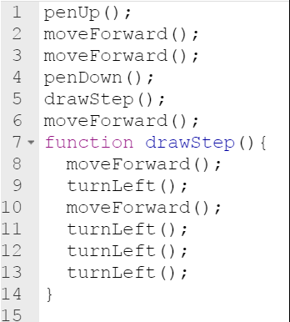

Call – is line 5
Defines – is line 7

Is it possible to have 2 functions with the same name but different codes? No

Is it possible to have 2 functions with different names but the same code? Yes

Lesson 3.6
What is the top down strategy?
Top Down Design - a problem solving approach (also known as stepwise design) in which you break down a system to gain insight into the sub-systems that make it up.

Explain how you use a top down strategy to draw the following picture:

Top-Down Design Strategy | Talking through the problem... | Function Name
Look at the big picture... | “Well, I need to draw a star…” | drawStar()
Identify a sub-task... | “...the star has 6 Sides I need to draw…” | drawSides()
Break down that sub-task into smaller sub-task(s)... | “...and each side is really 6 v-shapes …” | drawVShape()
Keep going until you have broken it down into further tasks...The student should have more steps. |  | Stop; when it is simple enough to program

Lesson 3.7
What is the API a collection of? Why would a programmer want to have access to it?
API - a collection of commands made available to a programmer
A well-documented library of functions provided in a programming language that helps to simplify complex programming tasks.
What is a parameter?
An extra piece of information passed to a function to customize it for a specific need.
Parameter: accepts a value to be passed to a function, typically affecting the behavior of that function (e.g., changing the distance the moveForward() command moves the turtle)
Why are they useful in building functions?
Parameters remove the need to create repetitive functions, making code easier to write, read, and change.

Where do you put the parameters when you define a function that has a parameter?
After the name of the function.

How do you call a function with a parameter?
NameOfFunction(value of parameter);
What is the parameter name when you define the function?
drawSquare
What lines in the function definition is the parameter referred to?
9, 11, 15
In the code what values are passed to the function when it is called?
100, 25
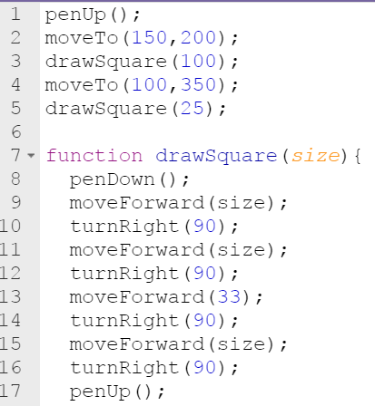

Lesson 3.9
What kind of loops have a predetermined beginning, end, and increment (step interval)?
For Loops

If you wanted to repeat a process a lot (such as 1000) times would you want to use a function or a loop? Why?
Write a function when you have a piece of code - a procedure - that you might reuse in other places in your program.
Write a loop when there is something you need to do over and over again and it doesn’t make sense to split it up any more.

If you wanted to draw several (such as 3) houses in a digital scene, would you want to use a function or a loop? Why?
A function because you only want to write the same code one time. Calling the same function 3 times is manageable. If you needed to all it 300 times, you would want to incorporate a loop.

If you wanted to create a shape that looks like the figure below, what command would be most efficient?
Loop

If you wanted to create a nighttime scene with lots of stars of different sizes in the sky, a loop would be useful, but what other command would you want to use?
Random

Use the code below to answer the questions on the right.
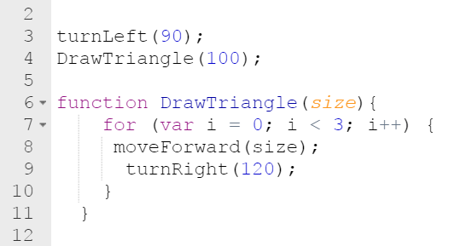
What line contains the command for a loop?
7
How many times does the loop repeat?
3
When the program runs what will you see? Be specific, shape and size.
Triangle – Each side equals 100

Lesson 3.10
Why do we use comments when creating codes?
A comment is a programmer-readable explanation in the code of a computer program. They are added with the purpose of making the code easier for humans to understand.

How are abstractions used in coding?
Abstraction - a simplified representation of something more complex. Abstractions allow you to hide details to help you manage complexity, focus on relevant concepts, and reason about problems at a higher level.

