What’s on the Computer Science Principles
1st Semester Final Exam?!?
Unit 1 – The Internet
Lesson 1.2
Know the difference between binary and non-binary questions.
- Write 2 examples of binary questions.

- Write 2 examples of non-binary questions.

Lesson 1.3
Define each of the following words: Bit Rate, Bandwidth, and Latency

Lesson 1.5
Know how to change numbers from decimal to binary and binary to decimal
- What is the decimal number 45 written as a binary number?

- What is the binary number 10011 written as a decimal number?

If you increase a binary number by 1 bit, how many more options will you have? How about 3 bits?

If McQueen High School offers 84 different classes, how many bits would they need in order to assign each class to a different binary number?

Lesson 1.6
What is the definition of a protocol, algorithm, and hierarchy?

Lesson 1.9
What is an IP address? And who/what are assigned IP addresses?

How many IP addresses could you create with 8 bits?

How many more IP addresses does IPv6 (128 bits) have than IPv4 (32 bits)?

Lesson 1.10
Know the following router vocabulary: Fault tolerant, redundancy, and the difference between routing
and broadcasting.
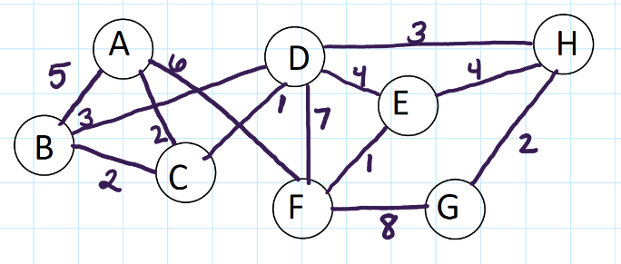
Be able to analyze network diagrams:
- What is the most efficient path from B to G?

- What number of connections can be lost so E can no longer communicate with H?

- How many connections could be removed and the network still be fault tolerant?

Lesson 1.11
Explain how packets are used to send data to a receiver.

When packets are sent what is contained in the message?

Why do we use packets to send data?

Lesson 1.12
Explain how the Domain Name System (DNS) works with IP addresses.

What is the purpose of the DNS?

Unit 2 – Digital Information
Lesson 2.1
Order the following file sizes from smallest to biggest
Megabyte, Exabyte, Kilobyte, Gigabyte, Terabyte, Petabyte

Lesson 2.2
What does it mean to take a heuristic approach to solving a problem?

Lesson 2.3
Define Metadata

If I was creating a digital picture by assigning each pixel an RGB value, what are some examples of metadata that you would want to include?

Lesson 2.4
What base number system is each of the following?
Decimal Binary Hexadecimal
Using 12 bits, four for each R, G, B value, Using 6 hexidecimals, 2 for each R, G, B, value,
How would you represent the following colors: (0-F)How would you represent the following colors:
- Red

- Green

- Blue

- White

- Black

Lesson 2.5
What is the difference between lossy and lossless compression.

Can you restore your data to its original state with lossy compression? Lossless compression?

What are the advantages and disadvantages of using a lossy compression?

What are the advantages and disadvantages of using a lossless compression?

Unit 3 – Intro to Programming
Lesson 3.4
What is pair programming and why do we us it? What are the roles of pair programming?

What picture would you create if you ran the following code?
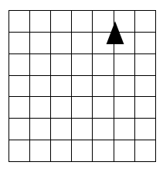
TurnLeft( )
Move Forward( )
Move Forward( )
Move Forward( )
TurnLeft( )
Move Forward( )
Move Forward( )
PenUp()
PenDown( )
TurnLeft()
Move Forward( )
Move Forward( )
Move Forward( )
TurnLeft( )
Move Forward( )
Move Forward( )

Using the four basic commands: PenUp( ), PenDown( ), MoveForward( ), TurnLeft( ), Write the most efficient program for creating a square with a side length of 2.

Lesson 3.5
Why do we create and use functions?

If I created a function for drawing a hexagon, what would be 2 good options for naming the function?

What would be a bad options for naming the function?

What is the difference between defining a function and calling a function?

Using the code below, which line calls the function? Which line defines the function?
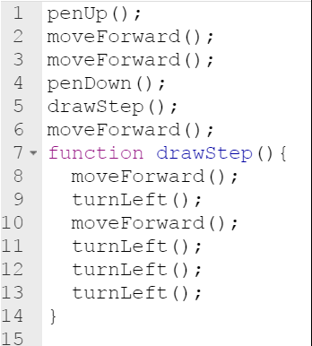

Is it possible to have 2 functions with the same name but different codes?

Is it possible to have 2 functions with different names but the same code?

Lesson 3.6
What is the top down strategy?

Explain how you use a top down strategy to draw the following picture:

Lesson 3.7
What is the API a collection of? Why would a programmer want to have access to it?

What is a parameter?

Why are they useful in building functions?

Where do you put the parameters when you define a function that has a parameter?

How do you call a function with a parameter?
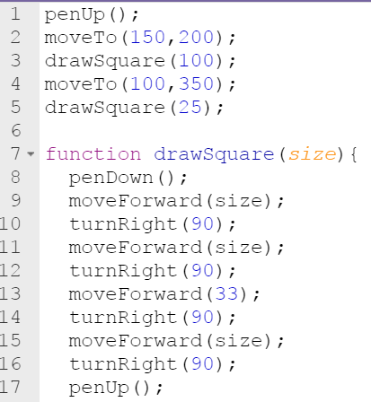
What is the parameter name when you define the function?

What lines in the function definition is the parameter referred to?

In the code what values are passed to the function when it is called?

Lesson 3.9
What kind of loops have a predetermined beginning, end, and increment (step interval)?

If you wanted to repeat a process a lot (such as 1000) times would you want to use a function or a loop? Why?

If you wanted to draw several (such as 3) houses in a digital scene, would you want to use a function or a loop? Why?

If you wanted to create a shape that looks like the figure below, what command would be most efficient?
If you wanted to create a nighttime scene with lots of stars of different sizes in the sky, a loop would be useful, but what other command would you want to use?

Use the code below to answer the questions on the right.
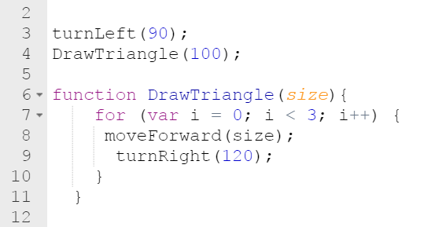
What line contains the command for a loop?

How many times does the loop repeat?

When the program runs what will you see? Be specific, shape and size.

Lesson 3.10
Why do we use comments when creating codes?

How are abstractions used in coding?

